WORLD LAPAROSCOPY HOSPITAL
Cyberciti, DLF Phase II, NCR Delhi, Gurgaon, 122 002, India
Phone: +91(0)12- 42351555 Mobile: +91(0)9811416838, 9811912768,
Email: contact@laparoscopyhospital.com
Click here for training detail

Laparoscopic repair of Duodenal Perforation

Duodenal perforation is a common complication of duodenal ulcer. Perforated duodenal ulcer is mainly a disease of young men but because of increasing smoking in women and use of NSAID in all the age group, now a day it is common in all adult population. In western society today it is a problem seen mainly in elderly women due to smoking alcohol and use of NSAID. Increased incidence in elderly is possibly due to increased NSAID use. 80% of perforated duodenal ulcers are H. pylori positive.
After perforation of duodenal ulcer, only treatment is its immediate surgical repair. The traditional management of perforated duodenal ulcer was Graham patch plication described in 1937. Laparoscopic repair of duodenal perforation by Graham patch plication is an excellent alternative approach.
Perforated duodenal ulcer is a surgical emergency. Laparoscopic repair of duodenal perforation is a useful method for reducing hospital stay, complications and return to normal activity. With better training in minimal access surgery now available, the time has arrived for it to take its place in the surgeon’s repertoire.
It appears that the laparoscopic approach has several advantages:
  - Cosmetically better outcome.
  - Less tissue dissection and disruption of tissue planes
  - Less pain postoperatively.
  - Low intra-operatively and postoperative complications.
  - Early return to work.
The main tasks of this operation consist of:
- Preparation of the patient.
- Creation of pneumoperitoneum. Insertion of port.
- Diagnostic laparoscopy and locating the perforation.
- Cleaning the abdomen.
- Closure of the perforation with an Omental patch.
- Irrigation and suction of operating field.
- Final Diagnostic laparoscopy for any bowel Injury or haemorrhage.
- Removal of the instrument with complete exit of CO2. Closure of wound.
Patient selection:
Duodenal perforation is a laparoscopic emergency. If the patient condition is otherwise fit and peritonitis is diagnosed within 12 hours of onset. It is possible to repair the perforation by laparoscopic method. After 12 hour chemical peritonitis will give way to bacterial peritonitis with severe sepsis and then the laparoscopic repair is not advisable.

OPERATIVE TECHNIQUE
Patient Position
- The patient is placed on the operating table with the legs in stirrups, the knees slightly bent and the hips flexed approximately 10°.
- The operating table is tilted head up by approximately 15 degree.
- Compression bandage are used on leg during the operation to prevent thromboembolism.
- The surgeon stands between the patient’s legs.
- The first assistant, whose main task is to position the video camera, sits on the patient’s left side.
- The instrument trolley is placed on the patient’s left allowing the scrub nurse to assist with placing the appropriate instruments in the operating ports.
- Television monitors are positioned on either side of the top end of the operating table at a suitable height so surgeon, anaesthetist, as well as assistant can see the procedure.

Anaesthesia:
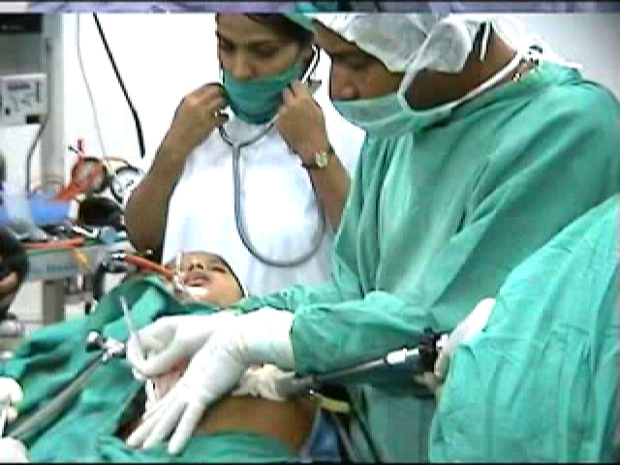
General Endotracheal Anaesthesia is used. Each patient is injected in the Pre-induction phase with 60mg IM Contramol, IV Metronidazole or Tinidazole and with 2grs. of Cefizox IV. The H2 receptor antagonist like ranitidine injection is also advisable.

Creation of Pneumoperitoneum.
- Check Veress needle before insertion.
- Check veress needle tip spring.
- Confirm that gas connection is functioning.
- Ensure flushing with saline does not block that needle.
- Make a small incision just above the umbilicus.
- Lift up abdominal wall and gently insert Veress needle till a feeling of giving way.
- Confirm position of needle by saline drop method.
- Connect CO2 tube to needle.
- Switch off gas when desired pneumoperitoneum is created and remove the Veress needle

Port location
- A 10mm camera port is placed in the umbilicus; this position will vary according the build of the patient.
- A 5mm port is inserted in the right upper quadrant 8-10 cm from the mid-line.
- A 5 mm port is placed in the left upper quadrant.
- A mirror image of the one on the patient’s right.
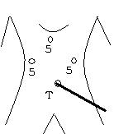
- Four ports are then inserted, using the triangulation concept, to form a diamond-shape. The surgeon usually stands between the legs of
- The patient, with the first assistant to the right and a second assistant to the left. The surgeon thus works comfortably with two
- Hands, triangulated between the cameras.

Locating the Perforation
- The gallbladder, which usually adheres to the perforation, is retracted by the surgeon’s left hand and moved upwards.
- The gallbladder is passed to the assistant using the sub xiphoid port which is placed to the right of the falciform ligament.
- The exposed area is checked and the perforation is usually clearly identified as a pinpoint hole on the anterior aspect of the duodenum.

Cleaning the Abdomen
- Irrigate and aspirate the whole abdomen with about 10 liters of saline mixed with local antibiotics.
- Each quadrant is cleaned methodically, starting at the right upper quadrant, going to the left, moving down to the left lower quadrant, and then finally over to the right.
- Special attention should be given to the vesicorectal pouch.
- Fibrous membranes are removed as much as possible, since they might contain bacteria.

Closure of the perforation with an omental patch
- Take a floppy piece of omentum flap
- Tell the assistant to hold the omentum patch just over the perforation
- Use both the hands to put intra-corporeal knot together with omental patch to seal the perforation.
- Always insert the omental patch in the knot rather than tail of the knot to hold the omentum because with the latter a small space remains between the knots.
- Don't use extra-corporeal knotting because this exerts tension on the friable tissue.

Ending of the operation.
- Examine the abdomen for any possible bowel injury or haemorrhage.
- Remove the Instrument and then port.
- Remove telescope leaving gas valve of umbilical port open to let out all the gas.
- Close the wound with Suture.
- Use vicryl for rectus and Un-absorbable intra-dermal or Stapler for skin.
- Apply adhesive sterile dressing over the wound.
- Patient may be discharged 2 days after operation if every thing goes well. The patient may have slight pain initially but usually resolves. The patient having any complain should be examined endoscopically after 3 to 4 week of operation. The proton pump inhibitor should be prescribed routinely.
For More Information Contact:
Laparoscopy Hospital
Unit of Shanti Hospital, 8/10 Tilak Nagar, New Delhi, 110018. India.
Phone:
+91(0)11- 25155202
+91(0)9811416838, 9811912768
Email: contact@laparoscopyhospital.com

Copyright © 2001 [Laparoscopyhospital.com]. All rights reserved.
Revised: .

